**ROLL NO : 78**

**PRACTICAL NAME :** Setup a GitHub Account and send the email message to friend telling to your friend about the account

**PRACTICAL NO :1.1**

* **Create a GitHub account :-**

If you don't already have a GitHub account, here's how to create one.

1. Open [https://github.com](https://github.com/) in a web browser, and then select **Sign up**.

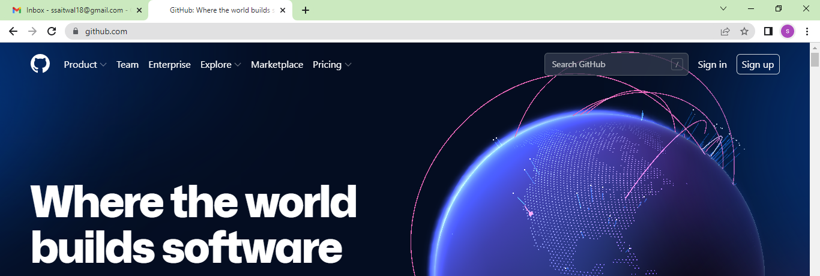

1. **Enter your email** address

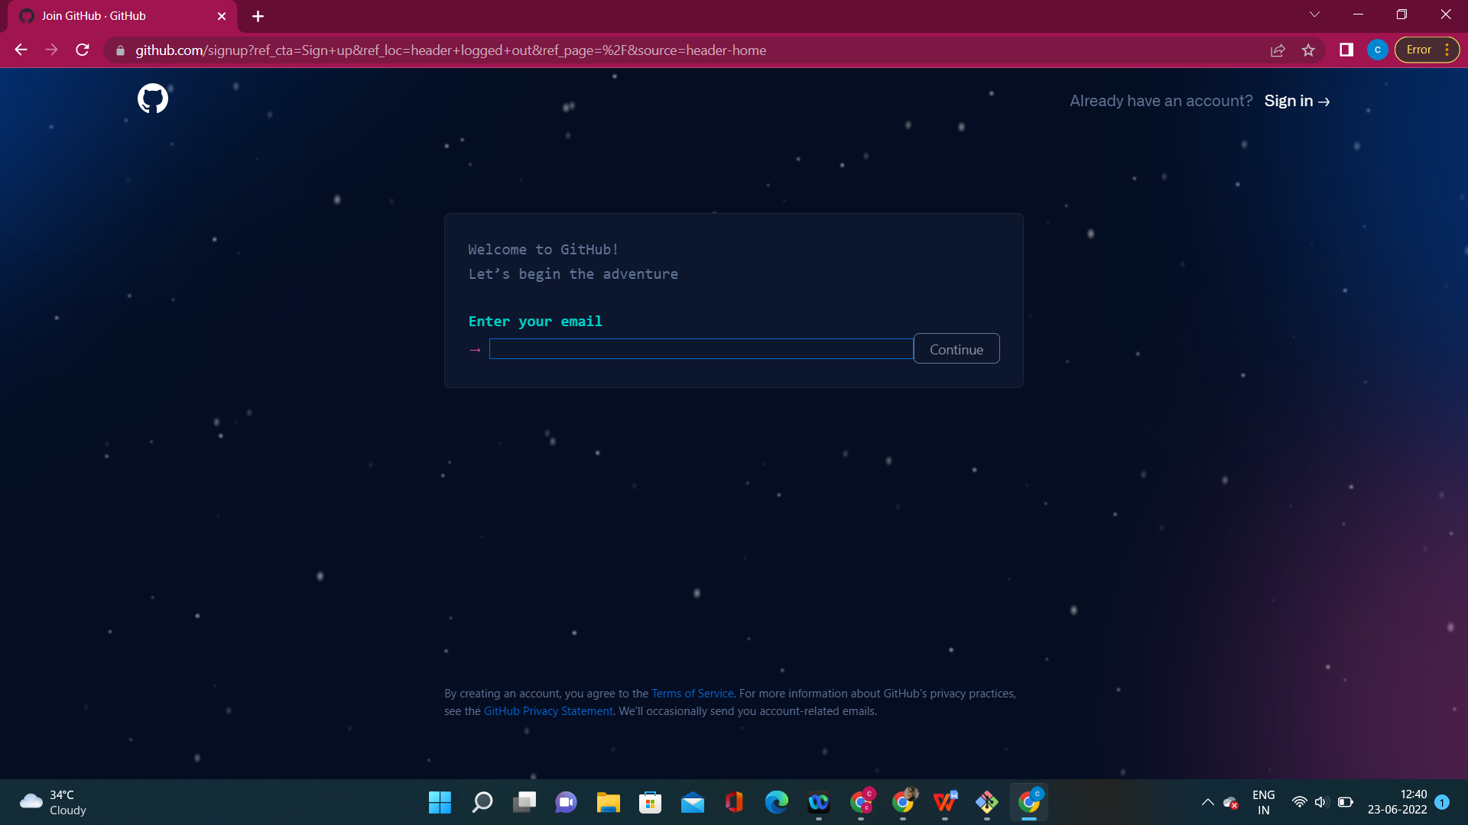

1. **Create a password** for your new GitHub account, and **Enter a username**, too. Next, choose whether you want to receive updates and announcements via email, and then select **Continue**
2. **Verify your account** by solving a puzzle. Select the **Start Puzzle** button to do so, and then follow the prompts.
3. After you verify your account, select the **Create account** button.
4. Next, GitHub sends a launch code to your email address. Type that launch code in the **Enter code** dialog, and then press **Enter**.

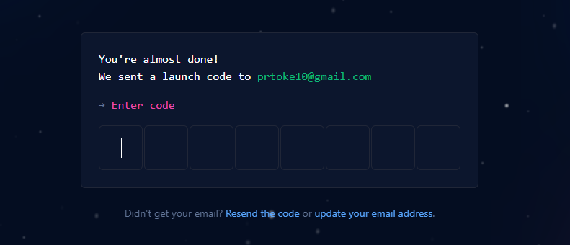

1. GitHub asks you some questions to help tailor your experience. Choose the answers that apply to you in the following dialogs:
   * **How many team members will be working with you?**
   * **What specific features are you interested in using?**

**8)** On the **Where teams collaborate and ship** screen, you can choose whether you want to use the Free account or the Team account. To choose the **Free** account, select the **Skip personalization** button

* GitHub opens a personalized page in your browser.

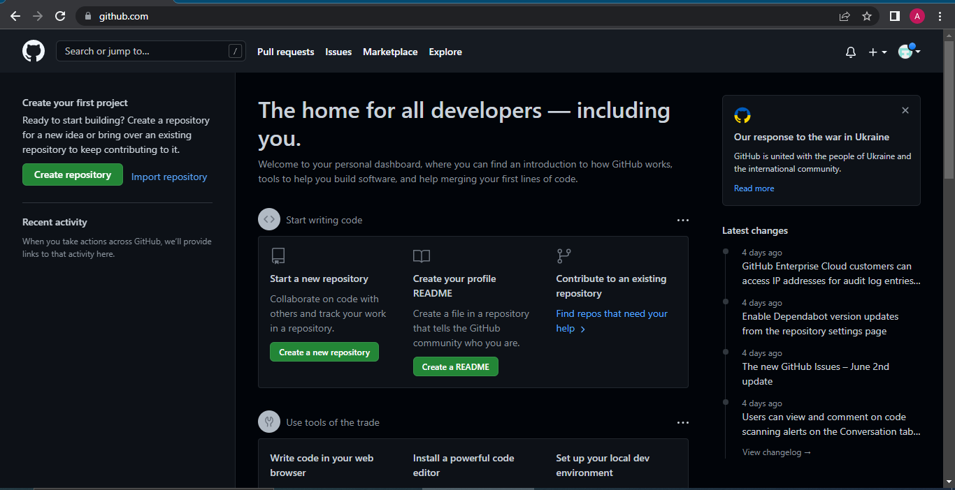

Congratulations! You've successfully created your GitHub account.

* **Paste the screen shots of email which you had sended to your friend from your Gmail account**

**ROLL NO : 14**

**PRACTICAL NAME :** **clone the repository at <https://github.com/KBCNMU>**

**PRACTICAL NO :1.2**

comp@comp MINGW32 ~

$ git --version

git version 2.36.1.windows.1

comp@comp MINGW32 ~

$ git --help

usage: git [--version] [--help] [-C <path>] [-c <name>=<value>]

[--exec-path[=<path>]] [--html-path] [--man-path] [--info-path]

[-p | --paginate | -P | --no-pager] [--no-replace-objects] [--bare]

[--git-dir=<path>] [--work-tree=<path>] [--namespace=<name>]

[--super-prefix=<path>] [--config-env=<name>=<envvar>]

<command> [<args>]

These are common Git commands used in various situations:

start a working area (see also: git help tutorial)

clone Clone a repository into a new directory

init Create an empty Git repository or reinitialize an existing one

work on the current change (see also: git help everyday)

add Add file contents to the index

mv Move or rename a file, a directory, or a symlink

restore Restore working tree files

rm Remove files from the working tree and from the index

examine the history and state (see also: git help revisions)

bisect Use binary search to find the commit that introduced a bug

diff Show changes between commits, commit and working tree, etc

grep Print lines matching a pattern

log Show commit logs

show Show various types of objects

status Show the working tree status

grow, mark and tweak your common history

branch List, create, or delete branches

commit Record changes to the repository

merge Join two or more development histories together

rebase Reapply commits on top of another base tip

reset Reset current HEAD to the specified state

switch Switch branches

tag Create, list, delete or verify a tag object signed with GPG

collaborate (see also: git help workflows)

fetch Download objects and refs from another repository

pull Fetch from and integrate with another repository or a local branch

push Update remote refs along with associated objects

'git help -a' and 'git help -g' list available subcommands and some

concept guides. See 'git help <command>' or 'git help <concept>'

to read about a specific subcommand or concept.

See 'git help git' for an overview of the system.

comp@comp MINGW32 ~

$ git clone https://github.com/ChanchalKPatil/KBCNMU1.git

Cloning into 'KBCNMU1'...

remote: Enumerating objects: 3, done.

remote: Counting objects: 100% (3/3), done.

remote: Compressing objects: 100% (2/2), done.

remote: Total 3 (delta 0), reused 0 (delta 0), pack-reused 0

Receiving objects: 100% (3/3), done.

**OUTPUT:-**

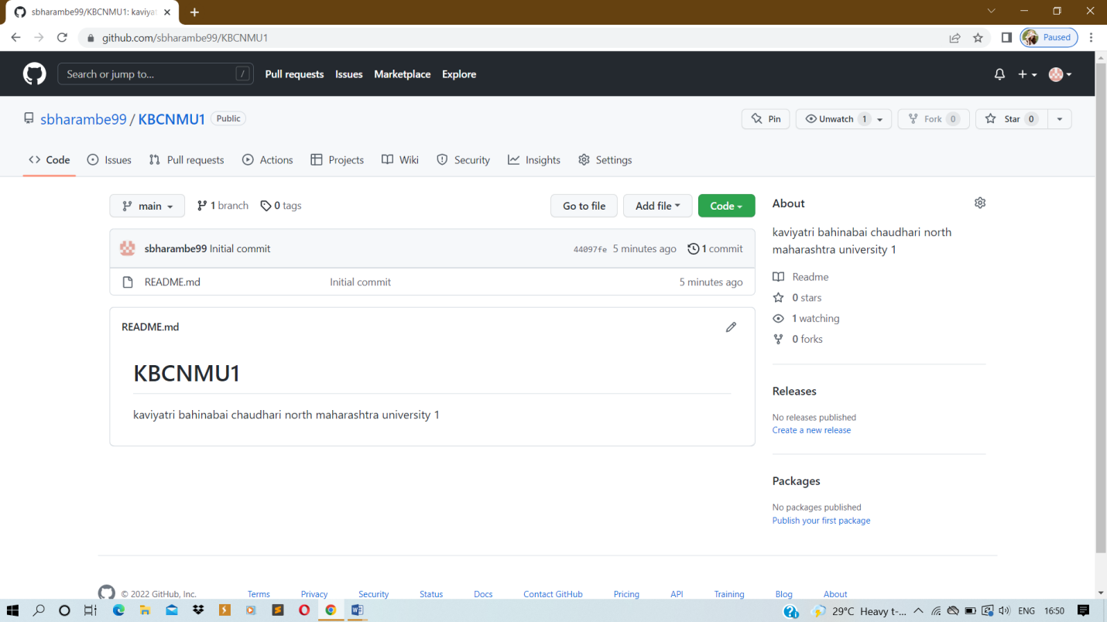

**ROLL NO : 14**

**PRACTICAL NAME :** Use git add that file to the primary repository . use git commit your change.

**PRACTICAL NO :1.3**

NEHA@LAPTOP-CAC84G1B MINGW64 ~

$ git clone https://github.com/sbharambe99/KBCNMU1.git

Cloning into 'KBCNMU1'...

remote: Enumerating objects: 3, done.

remote: Counting objects: 100% (3/3), done.

remote: Compressing objects: 100% (2/2), done.

remote: Total 3 (delta 0), reused 0 (delta 0), pack-reused 0

Receiving objects: 100% (3/3), done.

NEHA@LAPTOP-CAC84G1B MINGW64 ~

$ cd KBCNMU1

NEHA@LAPTOP-CAC84G1B MINGW64 ~/KBCNMU1 (main)

$ git init KBCNMU1

Initialized empty Git repository in C:/Users/NEHA/KBCNMU1/KBCNMU1/.git/

NEHA@LAPTOP-CAC84G1B MINGW64 ~/KBCNMU1 (main)

$ touch file1.txt

NEHA@LAPTOP-CAC84G1B MINGW64 ~/KBCNMU1 (main)

$ git add file1.txt

NEHA@LAPTOP-CAC84G1B MINGW64 ~/KBCNMU1 (main)

$ git commit -m "if .....else statement"

[main 91f352b] if .....else statement

1 file changed, 0 insertions(+), 0 deletions(-)

create mode 100644 file1.txt

NEHA@LAPTOP-CAC84G1B MINGW64 ~/KBCNMU1 (main)

$ git commit "-m third practical"

On branch main

Your branch is ahead of 'origin/main' by 1 commit.

(use "git push" to publish your local commits)

Untracked files:

(use "git add <file>..." to include in what will be committed)

KBCNMU1/

nothing added to commit but untracked files present (use "git add" to track)

NEHA@LAPTOP-CAC84G1B MINGW64 ~/KBCNMU1 (main)

$ git config --global user.name"sbharambe99"

NEHA@LAPTOP-CAC84G1B MINGW64 ~/KBCNMU1 (main)

$ git config --global user.email"sbharambe45@gmail.com"

NEHA@LAPTOP-CAC84G1B MINGW64 ~/KBCNMU1 (main)

$ git commit -m "if .....else statement"

[main 91f352b] if .....else statement

1 file changed, 0 insertions(+), 0 deletions(-)

create mode 100644 file1.txt

**BEFORE ADD:-**

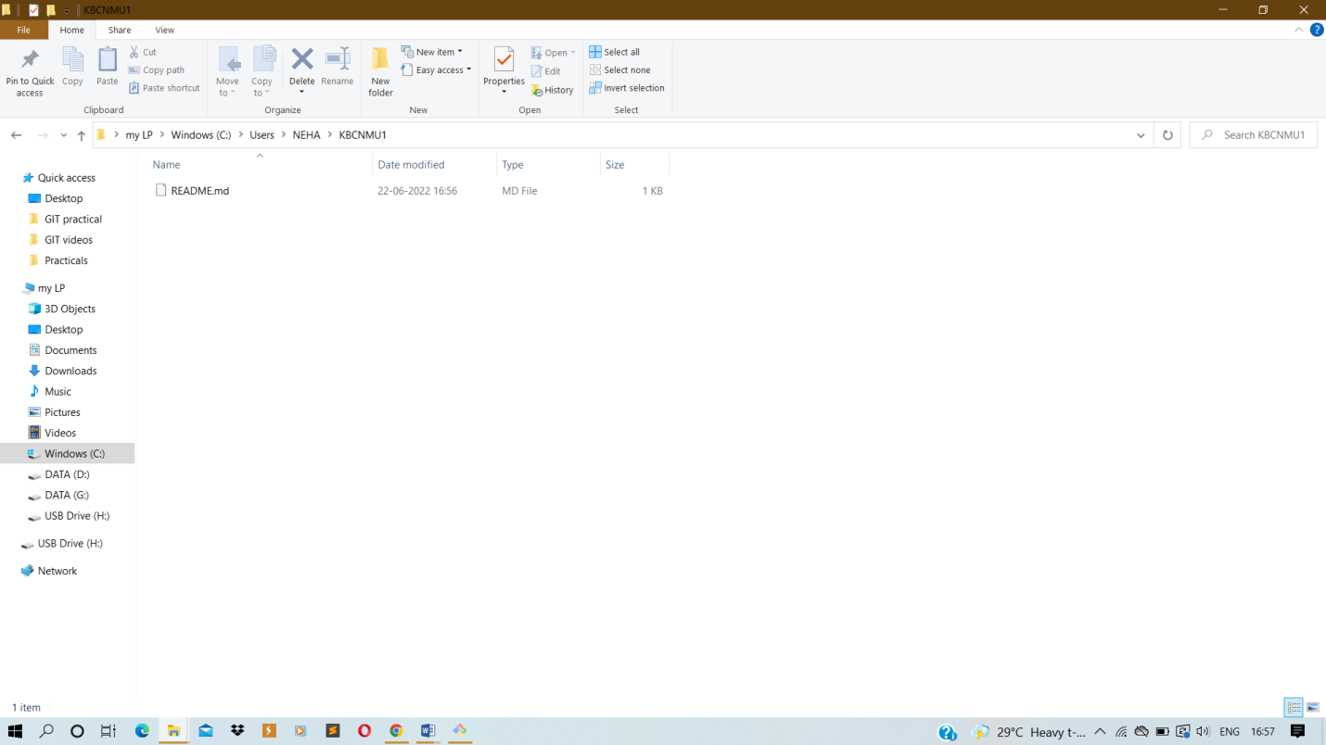

**AFTER ADD:-**

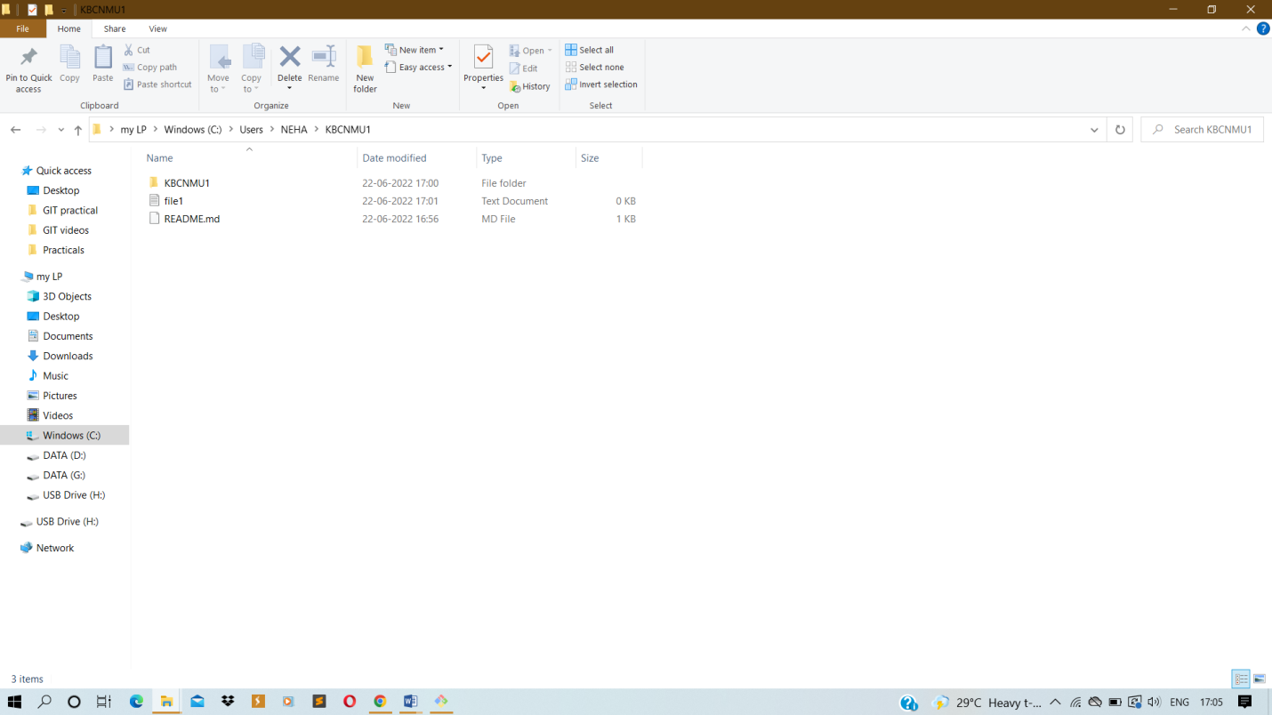

**ROLL NO : 14**

**PRACTICAL NAME :** Use git push to send your change to the primary repository . look online to see if your change has been pushed.

**PRACTICAL NO :1.4**

NEHA@LAPTOP-CAC84G1B MINGW64 ~

$ git clone https://github.com/sbharambe99/KBCNMU1.git

Cloning into 'KBCNMU1'...

remote: Enumerating objects: 3, done.

remote: Counting objects: 100% (3/3), done.

remote: Compressing objects: 100% (2/2), done.

remote: Total 3 (delta 0), reused 0 (delta 0), pack-reused 0

Receiving objects: 100% (3/3), done.

NEHA@LAPTOP-CAC84G1B MINGW64 ~

$ cd KBCNMU1

NEHA@LAPTOP-CAC84G1B MINGW64 ~/KBCNMU1 (main)

$ git init KBCNMU1

Initialized empty Git repository in C:/Users/NEHA/KBCNMU1/KBCNMU1/.git/

NEHA@LAPTOP-CAC84G1B MINGW64 ~/KBCNMU1 (main)

$ touch file1.txt

NEHA@LAPTOP-CAC84G1B MINGW64 ~/KBCNMU1 (main)

$ git add file1.txt

NEHA@LAPTOP-CAC84G1B MINGW64 ~/KBCNMU1 (main)

$ git commit -m "if .....else statement"

[main 91f352b] if .....else statement

1 file changed, 0 insertions(+), 0 deletions(-)

create mode 100644 file1.txt

NEHA@LAPTOP-CAC84G1B MINGW64 ~/KBCNMU1 (main)

$ git commit "-m third practical"

On branch main

Your branch is ahead of 'origin/main' by 1 commit.

(use "git push" to publish your local commits)

Untracked files:

(use "git add <file>..." to include in what will be committed)

KBCNMU1/

nothing added to commit but untracked files present (use "git add" to track)

NEHA@LAPTOP-CAC84G1B MINGW64 ~/KBCNMU1 (main)

$ git config --global user.name"sbharambe99"

NEHA@LAPTOP-CAC84G1B MINGW64 ~/KBCNMU1 (main)

$ git config --global user.email"sbharambe45@gmail.com"

NEHA@LAPTOP-CAC84G1B MINGW64 ~/KBCNMU1 (main)

$ git commit -m "if .....else statement"

[main 91f352b] if .....else statement

1 file changed, 0 insertions(+), 0 deletions(-)

create mode 100644 file1.txt

NEHA@LAPTOP-CAC84G1B MINGW64 ~/KBCNMU1 (main)

$ git push -u origin main

remote: Permission to sbharambe99/KBCNMU1.git denied to nehak1907.

fatal: unable to access 'https://github.com/sbharambe99/KBCNMU1.git/': The requested URL returned error: 403

**OUTPUT:-**

**BEFORE PUSH:**

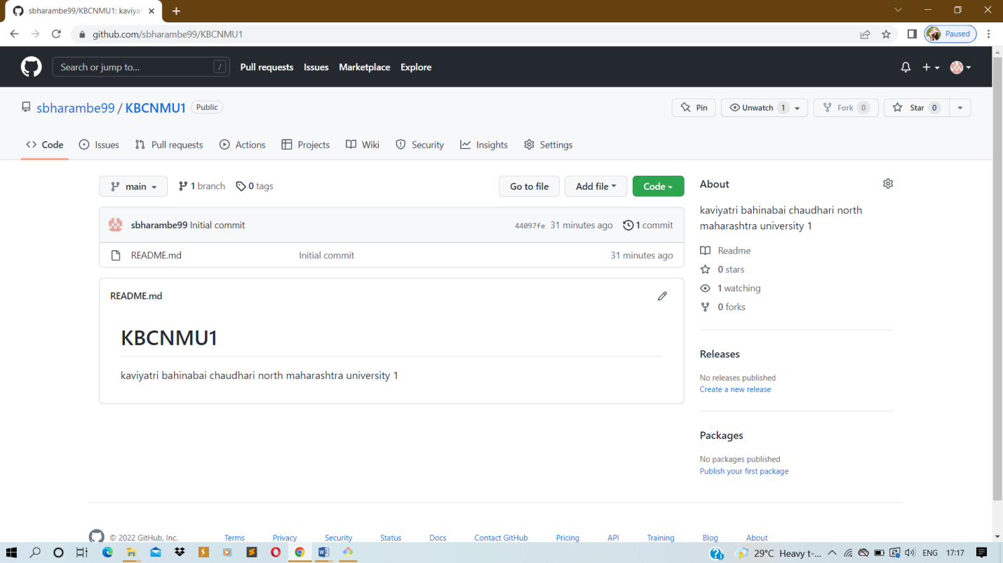

**AFTER PUSH:**

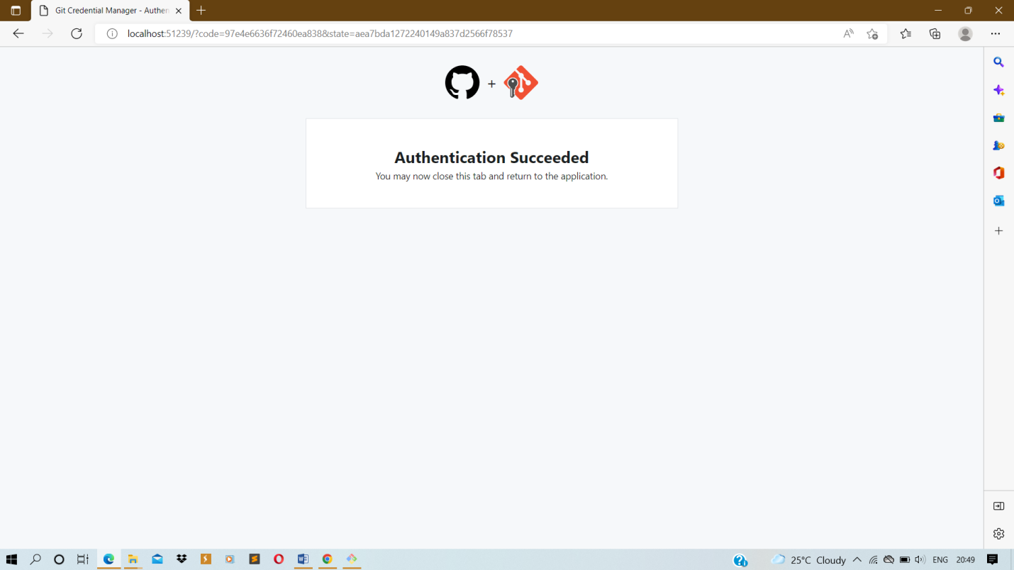

**Roll No:-**14

**Practical no:-1.**5

**Practical Name:-**Use git pull to get your parters change into your repository. Verify that you have the new file

comp@DESKTOP-HKJ9SS8 MINGW64 ~

$ git clone https://github.com/sbharambe99/KBCNMU1.git

Cloning into 'KBCNMU1'...

remote: Enumerating objects: 3, done.

remote: Counting objects: 100% (3/3), done.

remote: Total 3 (delta 0), reused 0 (delta 0), pack-reused 0

Receiving objects: 100% (3/3), done.

comp@DESKTOP-HKJ9SS8 MINGW64 ~

$ cd KBCNMU1

comp@DESKTOP-HKJ9SS8 MINGW64 ~/imr (main)

$ git init KBCNMU1

Initialized empty Git repository in C:/Users/comp/KBCNMU1/KBCNMU1/.git/

comp@DESKTOP-HKJ9SS8 MINGW64 ~/imr (main)

$ git pull https://github.com/sbharambe99/KBCNMU1.git

remote: Enumerating objects: 4, done.

remote: Counting objects: 100% (4/4), done.

remote: Compressing objects: 100% (3/3), done.

remote: Total 3 (delta 0), reused 0 (delta 0), pack-reused 0

Unpacking objects: 100% (3/3), 987 bytes | 49.00 KiB/s, done.

From https://github.com/sbharambe99/KBCNMU1

* branch HEAD -> FETCH_HEAD

Updating 631d491..91eb1f3

Fast-forward

CSCFile2.csv | 21 +++++++++++++++++++++

1 file changed, 21 insertions(+)

create mode 100644 CSVFile2.csv

